The DC Dentist
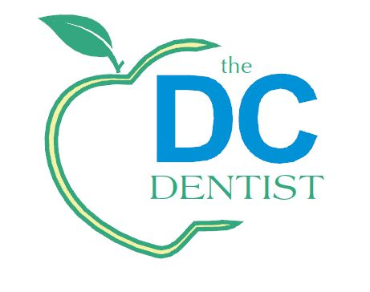
509 11TH Street SE
Washington, DC 20003
(202) 544 - 3626

HIPAA Consent Form
I understand that, under the Health Insurance Portability and Accountability Act of 1996 (HIPAA), I have certain right regarding my protected health information. I understand that this information can and will be used, but is not mandatory for me to sign in order to:
- Conduct, plan and direct my treatment and follow-up among the multiple healthcare providers who may be involved in that treatment directly and indirectly.
- Obtain payment from third-party payers
- Conduct normal healthcare operations such as quality assessments
- Certifications

I have been informed by you of your Notice of Privacy Practices containing a more complete description of the uses and disclosers of my health information. I have been given a copy of your Notice of Privacy Practices prior to signing this consent I understand that this organization had the right to change its Notice of Privacy Practices from time to time and that I may contact this organization at any time at the address above to obtain a current copy of the Notice of Privacy Practices.

I understand that I may request in writing that you restrict how my private information is used or disclose to carry out treatment, payment to healthcare operations. I also understand you are not required to agree to my requested restrictions but if you do agree then you are bound to abide by such restrictions.

I understand that I may revoke this consent in writing at any time, except to the extent that you have taken action relying on this consent.

Patient name: __________________________________________________________________

Signature: ______________________________________________________________________

Relationship to Patient: ___________________________________________________________

Date: _________________________________________________________________________

